**Karachi:**

Churna Island

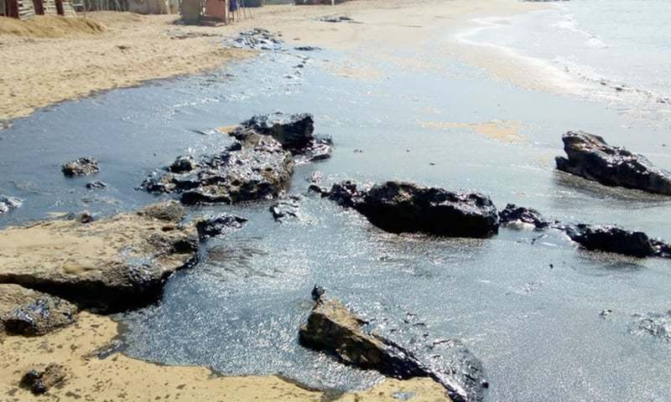

**Charna Island**( جزیرہ چرنا )is located near Mubarak Goth, Kiamari Town in Karachi, Sindh, Pakistan. Churna Island is a small uninhabited island located in the Arabian Sea, about 9km (5.6mi) west of the mouth of the Hub river called "Manjhar Beach", at the boundary between the provinces of Balochistan and Sindh. Charna is approximately 1.2km (0.75mi) long and 0.5km (0.31mi) wide. Charna is also locally known "Cheerno" and "Charna". It is 6km away from Mubarak Village. In winters (September to April) Local and foreigner tourist use to visit for adventure activities like Snorkeling, Cliff Diving, Scuba Diving, Spearfishing, Fishing Underwater photography with tour operator. Fishermen of Mubarak Goth go for fishing near the Charna Island. There are many species of fish, crabs and lobsters. Anglers take boats to go Island from Mubarak Goth. Mubarak Goth is a second largest fishermen locality in Karachi, which lacks facilities including education, health, jetty, ownership rights and communication etc.